Custom Protocol Simulation Project
Capstone Project Report
Unit Code: CSG3101 - Applied Project
Edith Cowan University
Date: September 2025

GROUP MEMBERS
STUDENT NAME: PHILLIP MWANGUKU
STUDENT ID: 10619172

STUDENT NAME: CHILUFYA JOSEPH KAWIMBE
STUDENT ID: 10620355

STUDENT NAME: WILSON MUGWE GATHII
STUDENT ID: 10641382

STUDENT NAME: DIPESH NEPAL
STUDENT ID: 10643078

STUDENT NAME: NAYARA ROCHELLE BAMUNUGE PERERA
STUDENT ID: 10662685

Phase 2 Design Report: Custom Protocol Specification
Table of Contents
Abstract 2
Introduction 3
Methodology and Design Approach 3
Packet Header Layout 4
Packet Layout Diagram 4
Message Types 5
Protocol Behavior 5
Use - Case Scenarios 6
Message Flow Diagrams 6
Discussion and Analysis 7

List of Figures
Figure 1: Custom protocol packet layout 5
Figure 2: Client–server state machine showing request/acknowledgment cycle with retransmission 6
Figure 3: Sequence diagram for successful request–acknowledgment exchange 7
Figure 4: Sequence diagram for corrupted packet and error handling 7

List of Tables
Table 1: Packet Header Structure 4

Abstract
This report documents the Phase 2 design of the custom protocol developed for the Custom Protocol Simulation Project. The work builds on Phase 1 research, where several formal specification languages were analysed. ASN.1 and Protocol Buffers were identified as lightweight and practical, and this design translates those findings into a working protocol specification. The report details the packet header structure, message types, behavioural mechanisms, and use-case scenarios. The resulting design achieves a balance between robustness and educational simplicity, preparing the foundation for Phase 3 implementation and testing.
Introduction
The increasing demand for lightweight, instructional networking protocols has highlighted the need for designs that are simple, robust, and analysable using common tools such as Scapy and Wireshark. This report presents the Phase 2 design of a custom communication protocol developed as part of the CSG3101 Applied Project capstone unit.
Phase 1 of the project evaluated a range of specification languages, including Estelle, LOTOS, SDL, ASN.1, and Protocol Buffers. Based on this research, ASN.1 and Protocol Buffers were identified as the most suitable due to their simplicity and widespread applicability. Phase 2 builds on this foundation by translating research into a concrete design, with explicit header fields, behavioural logic, and message flows.

Methodology and Design Approach
Phase 1 findings highlighted ASN.1 and Protocol Buffers as the most practical and lightweight frameworks for specifying new protocols. These were chosen due to their simplicity, flexibility, and suitability for educational use.
The design expands upon this foundation by defining header fields, fixed field sizes, and message semantics. The approach balances two key priorities:
- Ensuring the protocol is reliable and analysable in Scapy and Wireshark.
- Maintaining a level of simplicity suitable for instructional laboratories.

Packet Header Layout
The protocol employs a compact 8-byte header, followed by a variable-length payload. An optional checksum enhances error detection. Table 1 summarizes the header fields.
Field | Size | Type | Description
Version | 1 B | Uint8 | Identifying the protocol version
Type | 1 B | Uint8 | Defining the message  ( 0=Request, 1=Ack, 2=Response, 3=Error )
Seq | 2 B | Uint16 | Sequence number for retransmission and sorting.
Length | 2 B | Uint16 | Length of payload in bytes
CRC16 | 2 B | Uint16 | Optional 16-bit checksum across header and payload.
Table 1: Packet Header Structure
This structure ensures minimal overhead while still supporting sequence control, payload sizing, and integrity verification. As illustrated in Figure 1, the layout is compact and logical, making it easier for both implementers and analysts to follow.
Rationale:
- 1 byte each is sufficient because Version and Type are small values.
- 2 bytes (0-65,535) are standard since length and sequence can increase.
- Conventionally, CRC16 is two bytes, widely accepted, and easy to validate.

Packet Layout Diagram
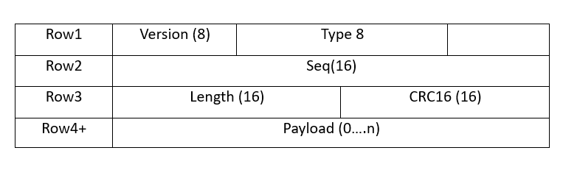

Figure 1: Custom protocol packet layout

Message Types
The protocol supports four message types, defined as follows:
- Request (0): Client initiates transmission of a command or data.
- Ack (1): Acknowledges receipt of a request and echoes the sequence number.
- Response (2): Provides optional data or confirmation from the server.
- Error (3): Indicates sequence mismatch, CRC failure, or corrupted transmission.

Protocol Behavior
The protocol employs a stop-and-wait Automatic Repeat Request (ARQ) mechanism. This allows easy observation of retransmissions in Wireshark and ensures reliable delivery.
Custom Protocol State Machine

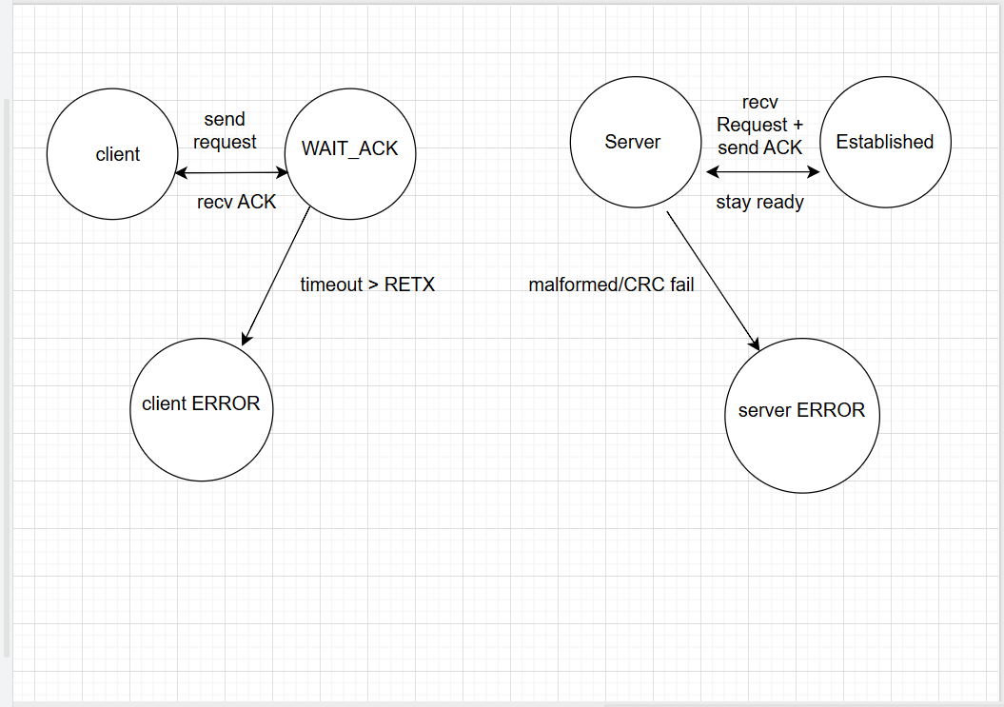

Figure 2: Client–server state machine showing request/acknowledgment cycle with retransmission

Use - Case Scenarios
Chat Example
- Clients sent Request (“Hello”, Seq=1).
- Server replied with Ack(1) and optional Response (“Hi !”).
- If not, Ack arrives, the client retransmits.

IoT Sensor Example
- Sensor sent Request (“temp=23.5”, Seq=n) in every 5 seconds.
- Gateway replied with Ack(n).
- If a packet is corrupted, the gateway responds with ERROR.

Message Flow Diagrams

Normal Flow
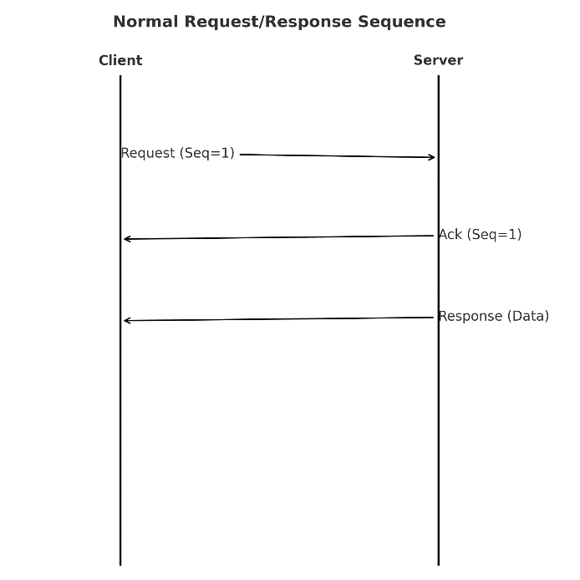

Figure 3: Sequence diagram for successful request–acknowledgment exchange

Error Flow
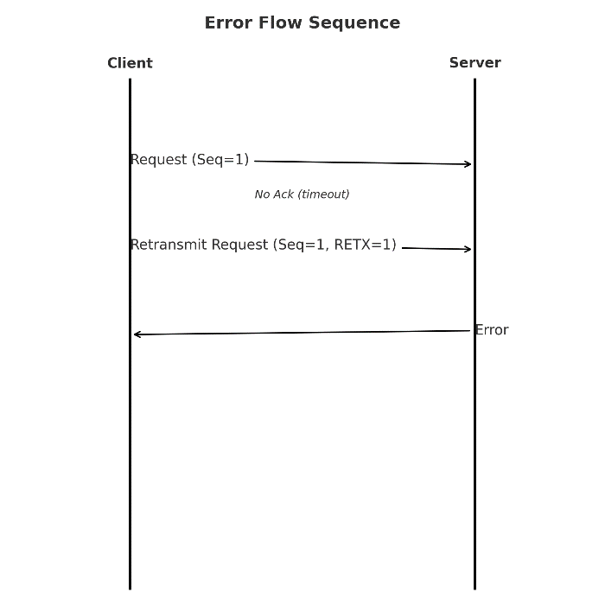

Figure 4: Sequence diagram for corrupted packet and error handling

Discussion and Analysis
The proposed protocol design offers several advantages:
- Simplicity: The design is intentionally lightweight, making it easy to implement in Scapy.
- Clarity: Explicit fields and distinct message types make packet analysis straightforward in Wireshark.
- Educational Value: The design prioritizes pedagogical clarity, making it suitable for instructional laboratories.
However, there are also limitations:
- Throughput Constraints: Stop-and-wait ARQ limits efficiency in high-traffic systems.
- Scalability: Fixed header fields restrict adaptability for more advanced use cases.
Despite these limitations, the protocol strikes the intended balance between robustness and simplicity. It is not intended for industrial-scale deployment but for academic demonstration and controlled testing, where clarity of operation is more important than throughput.
Conclusion
This Phase 2 report has outlined the design of a custom communication protocol, including packet structure, message types, behavioural logic, and use-case scenarios. The design ensures reliable delivery, enables clear analysis, and provides instructional value.
By deliberately focusing on simplicity, the design allows students to observe retransmissions, acknowledgments, and error handling with minimal complexity. At the same time, it ensures robustness by incorporating essential fields and checksum validation.
This work lays the groundwork for Phase 3, where the protocol will be implemented in Scapy, tested in Wireshark, and validated against the use cases outlined. The successful completion of Phase 2 provides a solid platform for moving from design into practical implementation.

